Inflammatory Cardiomyopathy

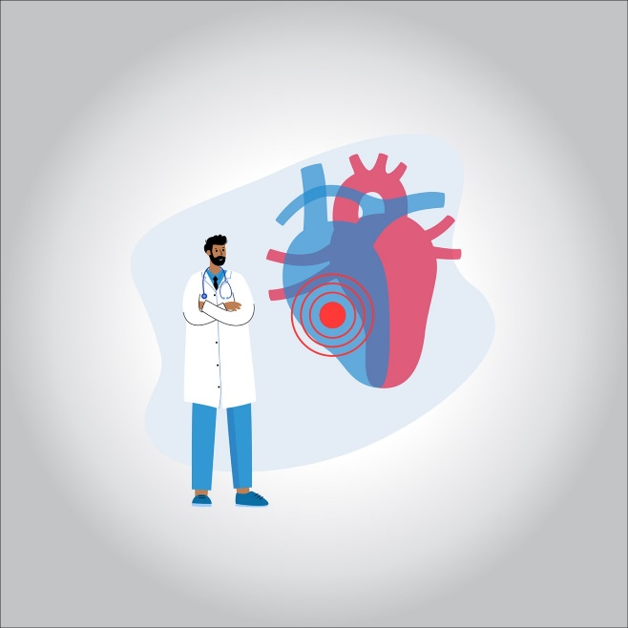

**Myocarditis is inflammation of the heart muscle (cardiomyopathy). Myocarditis can affect the heart muscle and the heart’s electrical system, reducing the heart’s ability to pump and causing fast or abnormal heart rhythms (arrhythmias)**

**Symptoms**

**Abnormal, fast heart rhythms (arrhythmia)**

**Shortness of breath at rest or during physical activity**

**Fluid retention and swelling in the legs, ankles, and feet**

**Exhaustion**

**Other signs and symptoms of a viral infection, such as headache, body aches, joint pain, fever, sore throat, or diarrhea**

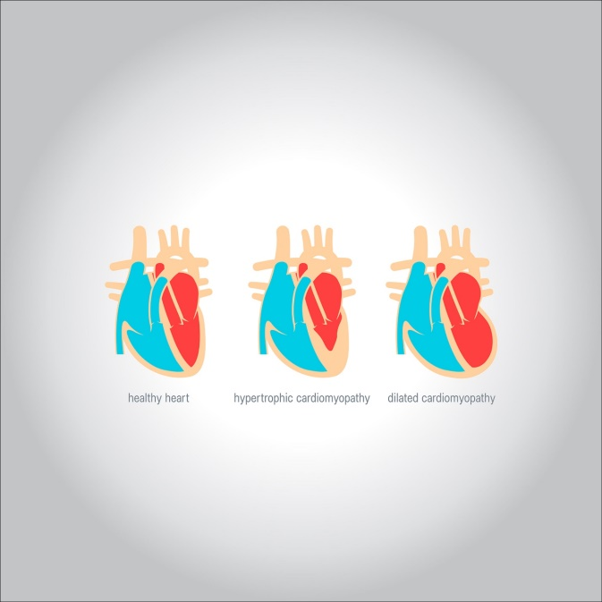

**The reasons**

**Viral infections (caused by the Coxsackie virus, herpes simplex, influenza, etc.), lesions of myocardial cells with toxins and allergens, disruption of immune and endocrine regulation, as well as a genetic predisposition, which causes improper formation and recruitment of myocardial fibers are considered . as possible causes.**

**Complications of inflammatory cardiomyopathy**

**Shortness of breath (dyspnea) when active or lying down Poor ability to exercise Swelling (edema) in the legs, ankles, feet, and abdomen Chest pain, heart palpitations, or irregular or fast heartbeats**

**Heart failure**

**Heart attack or stroke**

**Abnormal, fast heart rhythm (arrhythmia).**

**Sudden cardiac death**



**How to prevent cardiomyopathy**

**Make sure you follow your doctor’s instructions and stick to taking your medications as prescribed. Maintain a healthy lifestyle and make lifestyle changes as directed by your doctor. Early treatment of some diseases that may cause or increase the risk of developing cardiomyopathies, such as high blood fats, high pressure, and diabetes.**

**Inflammatory cardiomyopathy treatment**

**Myocarditis treatment focuses on the cause and symptoms, such as heart failure. In mild cases, individuals should avoid competitive sports for at least three to six months. Rest and medication may be all you need to help your body fight the infection that causes myocarditis**.